MATLAB SIMULATION OF SINGLE-BIT ERROR DETECTION AND CORRECTION USING SYNDROME VECTORS IN LINEAR BLOCK CODES
Analog and Digital Communication — Experiment 26
Date of Experiment | 12/10/2026
Performed By | Lokesh A
Register Number | 192512293
1. Aim
To simulate a (7,4) Hamming code in MATLAB, introduce a single-bit error into the encoded codeword, decode the received codeword, and observe the corrected message.
2. MATLAB Program
clc;
clear;
close all;
% (7,4) Hamming Code
msg = [1 0 1 1];
% Encode
code = encode(msg,7,4,'hamming/binary');
% Introduce Single-Bit Error
rx = code;
rx(3) = ~rx(3); % Flip one bit
% Decode and Correct Error
dec = decode(rx,7,4,'hamming/binary');
% Display Results
disp('Message Bits:')
disp(msg)
disp('Encoded Bits:')
disp(code)
disp('Received Bits (with error):')
disp(rx)
disp('Corrected Message:')
disp(dec)
% Plot
figure;
subplot(2,1,1)
stem(code,'filled')
title('Encoded Codeword')
grid on
subplot(2,1,2)
stem(rx,'filled')
title('Received Codeword with Single-Bit Error')
grid on
3. Output
The first plot shows the encoded Hamming codeword. The second plot shows the received codeword after one bit is flipped. The MATLAB Command Window displays the original message, encoded bits, received bits containing the error, and decoded message. The decoder is used to recover the message from the corrupted codeword.
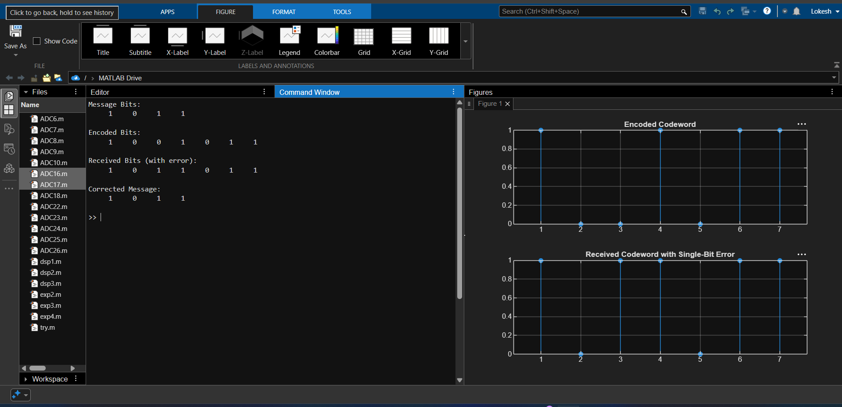
Figure 1: MATLAB command-window output and plotted encoded and received codewords.
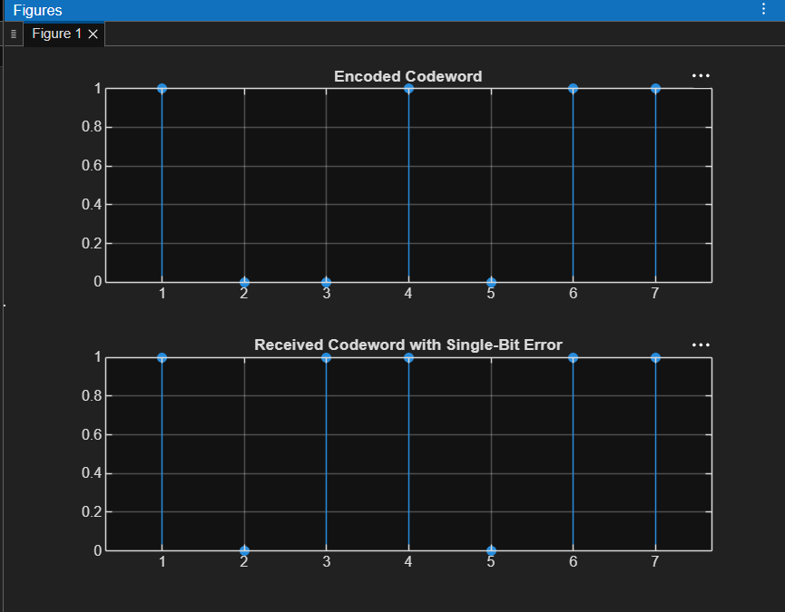
Figure 2: Encoded codeword compared with the received codeword containing a single-bit error.
4. Simulation Parameters
Parameter | Value
Block code | (7,4) Hamming code
Message bits | [1 0 1 1]
Codeword length | 7 bits
Message length | 4 bits
Error introduced | Single-bit error at position 3
Encoding function | encode(msg,7,4,'hamming/binary')
Decoding function | decode(rx,7,4,'hamming/binary')
5. Applications
- Error detection and correction in digital communication systems.
- Reliable data transmission over noisy communication channels.
- Error-control coding in data storage and transmission.
- Demonstrating single-bit error correction using Hamming codes.
6. Procedure
- Define the four-bit message sequence.
- Encode the message using the (7,4) Hamming code.
- Flip the bit at position 3 to simulate a single-bit transmission error.
- Decode the received codeword using the Hamming decoder.
- Display the message, encoded codeword, received codeword, and decoded message.
- Plot the encoded and corrupted codewords for comparison.
7. Result and Discussion
The simulation generates a Hamming codeword from the input message and introduces a single-bit error at the third position. The received codeword is then passed to the decoder, and the decoded message is displayed. The plots illustrate the difference between the original encoded codeword and the received codeword after the bit flip.
8. Conclusion
A (7,4) Hamming coding system was simulated in MATLAB to demonstrate single-bit error introduction and correction. The encoded and corrupted codewords were plotted, and the decoder output was displayed to illustrate the role of block codes in improving data reliability.
DONE BY
Lokesh A
Register Number: 192512293
B.E. Electronics and Communication Engineering (ECE)

